**PERSONALITY TEST APPLICATION**

**PROJECT**

Submitted in the VI semester

By

**NAMES REGISTER NUMBERS**

NIVEDHITHA B 2013321076042

SUPRAJA R 2013321076035

SRIYA S PILLAI 2013321076043



**DEPARTMENT OF MATHEMATICS WITH COMPUTER APPLICATIONS (SS)**

**ETHIRAJ COLLEGE FOR WOMEN (AUTONOMOUS)**

**CHENNAI – 600008**

**APRIL 2023**

**PERSONALITY TEST APPLICATION**

**PROJECT**

Submitted in the VI semester

By

**NAMES REGISTER NUMBERS**

NIVEDHITHA B 2013321076042

SUPRAJA R 2013321076035

SRIYA S PILLAI 2013321076043



**DEPARTMENT OF MATHEMATICS WITH COMPUTER APPLICATIONS (SS)**

**ETHIRAJ COLLEGE FOR WOMEN (AUTONOMOUS)**

**CHENNAI – 600008**

**APRIL 2023**



**ETHIRAJ COLLEGE FOR WOMEN (AUTONOMOUS)**

**CHENNAI – 600008**

**B.Sc** **MATHEMATICS WITH COMPUTER APPLICATIONS (SS)**

***BONAFIDE CERTIFICATE***

This is to certify that the project entitled “PERSONALITY TEST APPLICATION” was submitted during the academic year 2022 – 2023.

Date:

**Head of the Department**

**ACKNOWLEDGEMENT**

Every project whether big or small is successful largely due to the effort of a number of wonderful people who have always given their valuable advice and lent a helping hand. The success and final outcome of our project required a lot of guidance and assistance from many people and we are extremely fortunate to have this all along the completion of our project work, whatever we have done is only due to such guidance and assistance and we would not forget to thank them.

#### We take great pleasure in expressing our sincere thanks to the principal,

#### Dr. S. Uma Gowrie who had given us the opportunity to carry out this project.

#### We also express our sincere gratitude to Dr. K. Prasanna Lakshmi, M.Sc., M.Phil., Ph.D, Head, Department of Mathematics with Computer Applications (SS), Ethiraj College for Women,Chennai for her support.

We also thank our faculty members **Mrs. S.Vasanthi, Mrs. M.R.Rathika, Mrs. A.Monisha, Mrs. G.Sandhya** and **Mrs. Hannah Bright**, Department of Mathematics with Computer Applications for their help and support.

We hereby thank our family and friends for their immense help and continuous inspiration.

PERSONALITY test application

Using Python programming



**INDEX**

|  |  |  |
| --- | --- | --- |
| **S.NO.** | **TOPICS** | **PAGE NO.** |
| **1.** | INTRODUCTION | 3 |
| **2.** | THE MYERS-BRIGGS PERSONALITY TEST | 4 |
| **3.** | PRE-REQUISITES | 9 |
| **4.** | BUILDING THE APP | 9 |
| **5.** | SOURCE CODE | 11 |
| **6.** | CONCLUSION | 19 |
| **7.** | BIBLIOGRAPHY | 19 |

**INTRODUCTION**

April, 2023.

**Topic :** Personality test

**Languages :** Python

Have you ever heard someone describe themselves as an INTJ or an ESTP and wondered what those cryptic-sounding letters could mean? What these people are referring to is their personality type based on the Myers-Briggs Type Indicator (MBTI).

In this project, we will take a cursory look into how we can effectively use python lists and functions to design a console app that makes use of Python’s data structures in a clear and understandable manner.

We are going to design a personality test app that makes use of test questions from Myers Briggs questionnaires.

**HOW DOES THE MYERS-BRIGGS PERSONALITY TEST WORK?**

The questionnaire was developed by Isabel Myers and her mother Katherine Briggs based on their work with Carl Jung’s theory of personality types. Today, the MBTI inventory is one of the world’s most widely used psychological instruments. There are several indices for testing people’s identities, but we focus our test on questions from Myers Briggs parameters which are:

1. Introvert or Extrovert.
2. Sensing or Intuitive.
3. Judging or Perceiving.
4. Thinking or Feeling.

At the end of each of the four sections, we pick the highest value from each of the sections above to compute a personality identity type. The identity types are divided into 16. The goal of the MBTI is to allow respondents to further explore and understand their own personalities including their likes, dislikes, strengths, weaknesses, possible career preferences, and compatibility with other people.

No one personality type Is “best” or “better” than another. It isn’t a tool designed to look for dysfunction or abnormality. Instead, its goal is simply to help you learn more about yourself. The questionnaire itself is made up of four different scales.

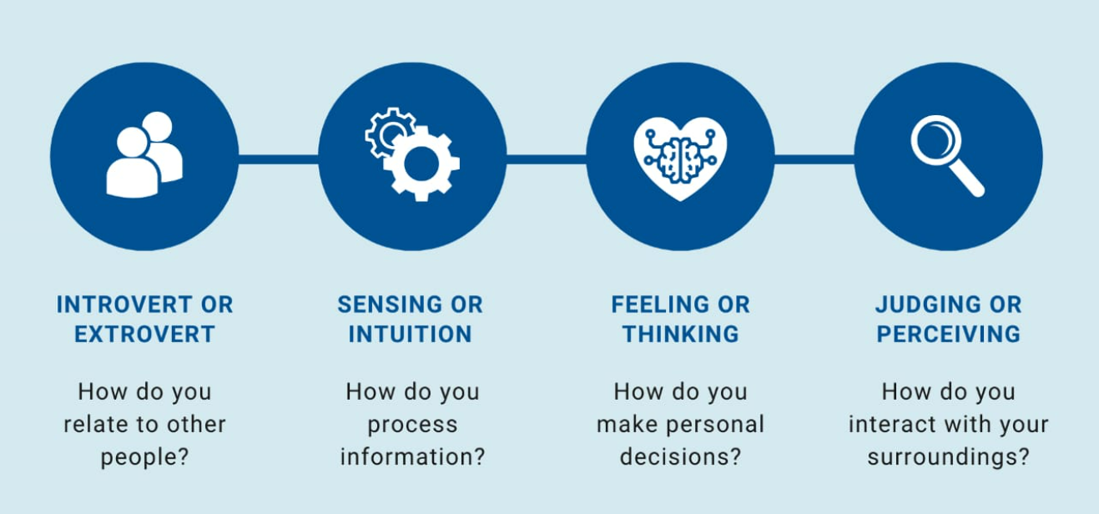

**Extraversion (E) – Introversion (I):**

The extraversion-introversion dichotomy was first explored by Jung in his theory of personality types as a way to describe how people respond and interact with the world around them. While these terms are familiar to most people, the way in which they are used in the MBTI differs somewhat from their popular usage.

Extraverts (also often spelled extroverts) are “outward-turning” and tend to be action-oriented, enjoy more frequent social interaction, and feel energized after spending time with other people. Introverts are “inward-turning” and tend to be thought-oriented, enjoy deep and meaningful social interactions, and feel recharged after spending time alone.

We all exhibit extraversion and introversion to some degree, but most of us tend to have an overall preference for one or the other.

**Sensing (S) – Intuition (N):**

This scale involves looking at how people gather information from the world around them. Just like with extraversion and introversion, all people spend some time sensing and intuiting depending on the situation. According to the MBTI, people tend to be dominant in one area or the other.

People who prefer sensing tend to pay a great deal of attention to reality, particularly to what they can learn from their own senses. They tend to focus on facts and details and enjoy getting hands-on experience. Those who prefer intuition pay more attention to things like patterns and impressions. They enjoy thinking about possibilities, imagining the future, and abstract theories.

**Thinking (T) – Feeling (F):**

This scale focuses on how people make decisions based on the information that they gathered from their sensing or intuition functions. People who prefer thinking place a greater emphasis on facts and objective data.

They tend to be consistent, logical, and impersonal when weighing a decision. Those who prefer feeling are more likely to consider people and emotions when arriving at a conclusion.

**Judging (J) – Perceiving (P):**

The final scale involves how people tend to deal with the outside world. Those who lean toward judging prefer structure and firm decisions. People who lean toward perceiving are more open, flexible, and adaptable. These two tendencies interact with the other scales.

Remember, all people at least spend some time engaged in extraverted activities. The judging-perceiving scale helps describe whether you behave like an extravert when you are taking in new information (sensing and intuiting) or when you are making decisions (thinking and feeling).

**THE MYERS-BRIGGS PERSONALITY TEST:**

* [**ISTJ - The Inspector**](https://www.verywellmind.com/istj-introversion-sensing-thinking-judgment-2795992)**:** Reserved and practical, they tend to be loyal, orderly, and traditional.
* [**ISTP - The Crafter**](https://www.verywellmind.com/istp-introverted-sensing-thinking-perceiving-2795993)**:** Highly independent, they enjoy new experiences that provide first-hand learning.
* [**ISFJ - The Protector**](https://www.verywellmind.com/isfj-introverted-sensing-feeling-judging-2795990)**:** Warm-hearted and dedicated, they are always ready to protect the people they care about.
* [**ISFP - The Artist**](https://www.verywellmind.com/isfp-introverted-sensing-feeling-perceiving-2795991)**:** Easy-going and flexible, they tend to be reserved and artistic.
* [**INFJ - The Advocate**](https://www.verywellmind.com/infj-introverted-intuitive-feeling-judging-2795978)**:** Creative and analytical, they are considered one of the rarest Myers-Briggs types.3
* [**INFP - The Mediator**](https://www.verywellmind.com/infp-a-profile-of-the-idealist-personality-type-2795987)**:** Idealistic with high values, they strive to make the world a better place.
* [**INTJ - The Architect**](https://www.verywellmind.com/intj-introverted-intuitive-thinking-judging-2795988)**:** High logical, they are both very creative and analytical.4
* [**INTP - The Thinker**](https://www.verywellmind.com/intp-introverted-intuitive-thinking-perceiving-2795989)**:** Quiet and introverted, they are known for having a rich inner world.
* [**ESTP - The Persuader**](https://www.verywellmind.com/estp-extraverted-sensing-thinking-perceiving-2795986)**:** Out-going and dramatic, they enjoy spending time with others and focusing on the here-and-now.
* [**ESTJ - The Director**](https://www.verywellmind.com/estj-extraverted-sensing-thinking-judging-2795985)**:** Assertive and rule-oriented, they have high principles and a tendency to take charge.
* [**ESFP - The Performer**](https://www.verywellmind.com/esfp-extraverted-sensing-feeling-perceiving-2795984)**:** Outgoing and spontaneous, they enjoy taking center stage.
* [**ESFJ - The Caregiver**](https://www.verywellmind.com/esfj-extraverted-sensing-feeling-judging-2795983)**:** Soft-hearted and outgoing, they tend to believe the best about other people
* [**ENFP - The Champion**](https://www.verywellmind.com/enfp-an-overview-of-the-champion-personality-type-2795980)**:** Charismatic and energetic, they enjoy situations where they can put their creativity to work.
* [**ENFJ - The Giver**](https://www.verywellmind.com/enfj-extraverted-intuitive-feeling-judging-2795979)**:** Loyal and sensitive, they are known for being understanding and generous.
* [**ENTP - The Debater**](https://www.verywellmind.com/the-entp-personality-type-and-characteristics-2795982)**:** Highly inventive, they love being surrounded by ideas and tend to start many projects (but may struggle to finish them).
* [**ENTJ - The Commander**](https://www.verywellmind.com/entj-personality-type-2795981)**:** Outspoken and confident, they are great at making plans and organizing projects.

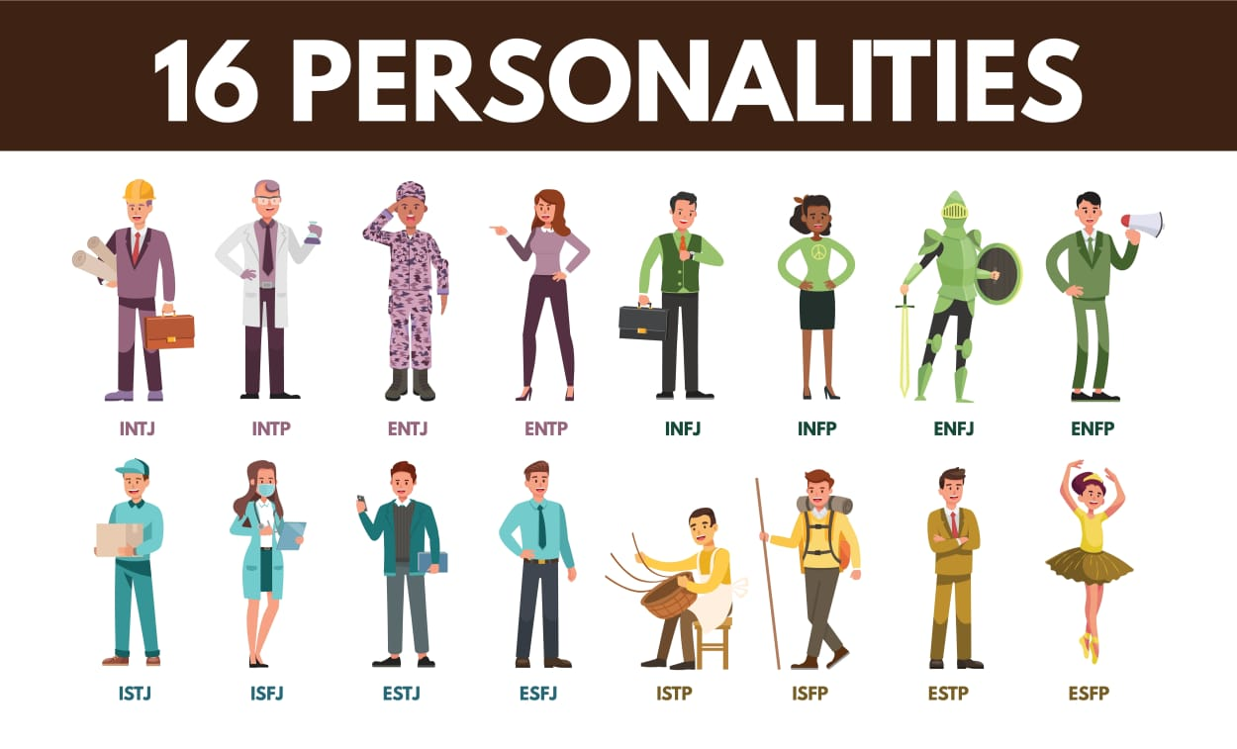

**PRE-REQUISITES:**

1. Python 3.0 and above
2. A text editor
3. Personality test questions from Myers Briggs
4. Python compiler (system software or mobile app)

**BUILDING THE APP:**

**Create a Python file:**

The first step towards building the test app is to create a python file, we can call it personality.py.

**Import the python module sys:**

In this module, we would use the exit() function to terminate the first interactive option we want to give our users.

**The run function:**

In the run function, we set variables to keep track of users’ options, which helps us compute the personality identities as they enter them. The variables are meant to count the occurrence of A’s and B’s as answers, and then use that to compute the identity accordingly.

**Exception handling:**

The code snippet handles the problem of incorrect input from the user. We only want the user to enter A or B. If our expected letter is entered, we count its occurrence.

We use our variable counters and if statements to compute the personality identity. The count keeps track of the questions ranging from 1 to 20 and a total of four sections.

The sectioning of the questions is in four parts with five questions each, making a total of 20 questions. We compute the dominant personality identity at every section of the test.

**Quit the app with exit function:**

This is a separate function that allows the user to exit the application. The sys module here enables us to exit from the terminal if the user decides not to take the test.

**Homepage function:**

This function is designed to mimic a landing page on the web. We only accept two options (1 or 2). We also checked for wrong inputs using python exception handling.

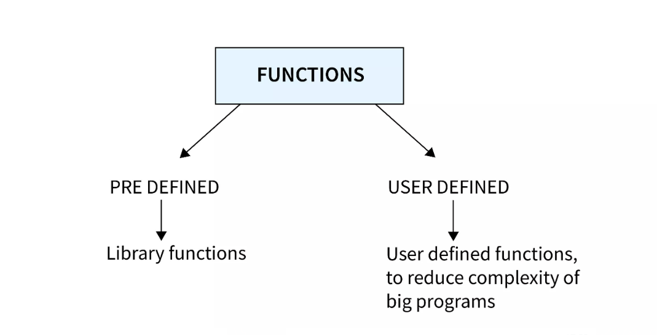

**SOURCE CODE:**

import sys

def display(personality_type):

print(f”Your personality type is -> {personality_type}”)

def run():

print(f”Welcome to Myers-Briggs personality test:”)

print(f”Please pick your choice of answer for each question:”)

questions: list = [

“””

Question 1:

a.I enjoy groups

b.I enjoy one-on-one

“””,

“””

Question 2:

a.I’m more outgoing

b.I’m more reserved

“””,

“””

Question 3:

a.I seek many tasks, public activities, interaction with others

b.I seek private, solitary activities with solitude

“””,

“””

Question 4:

a.I’m communicative and express myself

b.I’m reticent and like to keep to myself

“””,

“””

Question 5:

a.I’m active and initiative

b.I’m reflective and deliberate

“””,

“””

Question 6:

a.I interpret literally

b.I look for meaning and possibilities

“””,

“””

Question 7:

a.I’m practical, realistic and experimental

b.I’m imaginative, innovative and theoretical

“””,

“””

Question 8:

a.I’m standard, usual and conventional

b.I like to be different, novel and unique

“””,

“””

Question 9:

a.I focus on here-and-now

b.I look to the future, global perspective and “big picture”

“””,

“””

Question 10:

a.Fond of facts, things, “what is”

b.Fond of ideas, dreams, “what could be”

“””,

“””

Question 11:

a.I’m logical, thinking, questioning

b.I’m empathetic, feeling, accommodating

“””,

“””

Question 12:

a.I’m candid, straight forward and frank

b.I’m tactful, kind and encouraging

“””,

“””

Question 13:

a.I’m firm, tend to criticize and hold the line

b.I’m gentle, tend to appreciate and conciliate

“””,

“””

Question 14:

a.I’m tough-minded

b.I’m tender-hearted

“””,

“””

Question 15:

a.I’m matter of fact, issue-oriented

b.I’m sensitive, people-oriented, compassionate

“””,

“””

Question 16:

a.I’m organized and orderly

b.I’m flexible and adaptable

“””,

“””

Question 17:

a.I plan and schedule

b.I’m spontaneous

“””,

“””

Question 18:

a.I’m regulated, structured

b.I’m easygoing, “live” and “let live”

“””,

“””

Question 19:

a.I plan ahead

b.I go with the flow

“””,

“””

Question 20:

a.I like control

b.I like freedom

“””

]

count_of_a: int = 0

count_of_b: int = 0

personality_dichotomy: str = ‘’

count = 0

for question in questions:

answer = ‘’

while not (answer == ‘A’ or answer == ‘B’):

count_of_a = 0

count_of_b = 0

try:

answer = input(question).upper()

if not (answer == ‘A’ or answer == ‘B’):

raise ValueError(“Invalid input”)

except ValueError as error:

print(error)

else:

if answer == ‘A’:

count_of_a = count_of_a + 1

if answer == ‘B’:

count_of_b = count_of_b + 1

count = count + 1

if count == 5:

if count_of_a > count_of_b:

personality_dichotomy = personality_dichotomy + ‘E ‘

else:

personality_dichotomy = personality_dichotomy + ‘I ‘

else:

if count == 10:

if count_of_a > count_of_b:

personality_dichotomy = personality_dichotomy + ‘S ‘

else:

personality_dichotomy = personality_dichotomy + ‘N ‘

else:

if count == 15:

if count_of_a > count_of_b:

personality_dichotomy = personality_dichotomy + ‘T ‘

else:

personality_dichotomy = personality_dichotomy + ‘F ‘

else:

if count == 20:

if count_of_a > count_of_b:

personality_dichotomy = personality_dichotomy + ‘J ‘

else:

personality_dichotomy = personality_dichotomy + ‘P ‘

display(personality_dichotomy)

def exit_application():

print(“Exiting application…”)

sys.exit(0)

def main():

user_input = input(“””

welcome to the Meyers Briggs Personality Test

press 1 to take test

press 2 to exit application -> “””)

try:

if not (user_input == “1” or user_input == “2”):

raise ValueError(“Invalid input”)

except ValueError as error:

print(error)

else:

switcher = {

“1”: run,

“2”: exit_application

}

return switcher.get(user_input)()

if __name__ == “__main__”:

main()

**CONCLUSION:**

At the end of this article, we should be able to implement the use of python lists together with functions and exception handling to build a console app that computes a personality identity.

**BIBLIOGRAPHY:**

1. Myers Briggs personality type indicators by verywellmind.com
2. Introduction to computers and python by pyCDs books